Automated S3 Bucket Cleanup using AWS Lambda and Boto3

Objective
To automate the deletion of files older than 30 days in an Amazon S3 bucket using AWS Lambda and Boto3.

Tools & Technologies Used
• AWS S3
• AWS Lambda
• IAM (Identity and Access Management)
• Python (Boto3 SDK)

Implementation Steps

1. S3 Bucket Setup
A new S3 bucket was created and multiple files were uploaded for testing cleanup functionality.

2. IAM Role Creation
An IAM role was created for Lambda with AmazonS3FullAccess policy to allow access to S3 operations.

3. Lambda Function Creation
A Lambda function was created using Python runtime and assigned the IAM role.
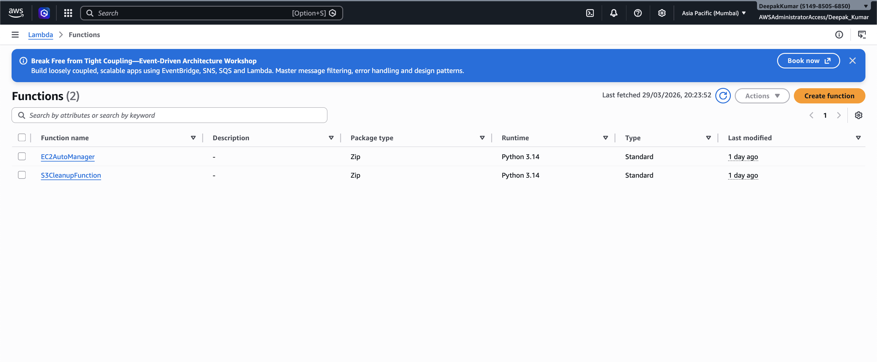

4. Lambda Function Code
import boto3
from datetime import datetime, timezone, timedelta
def lambda_handler(event, context):
s3 = boto3.client('s3')
bucket_name = 'your-bucket-name'
days_old = 30
cutoff_date = datetime.now(timezone.utc) - timedelta(days=days_old)
response = s3.list_objects_v2(Bucket=bucket_name)
if 'Contents' not in response:
print("No files found in bucket")
return
for obj in response['Contents']:
file_name = obj['Key']
last_modified = obj['LastModified']
if last_modified < cutoff_date:
print(f"Deleting: {file_name}")
s3.delete_object(Bucket=bucket_name, Key=file_name)
return {
'statusCode': 200,
'body': 'S3 cleanup completed'
}

5. Testing and Results
The Lambda function was tested manually for 1-day older files jest to check the execution as I do not have the files older that 30 days in S3 bucket. Files older than 1 day were successfully deleted from the S3 bucket.
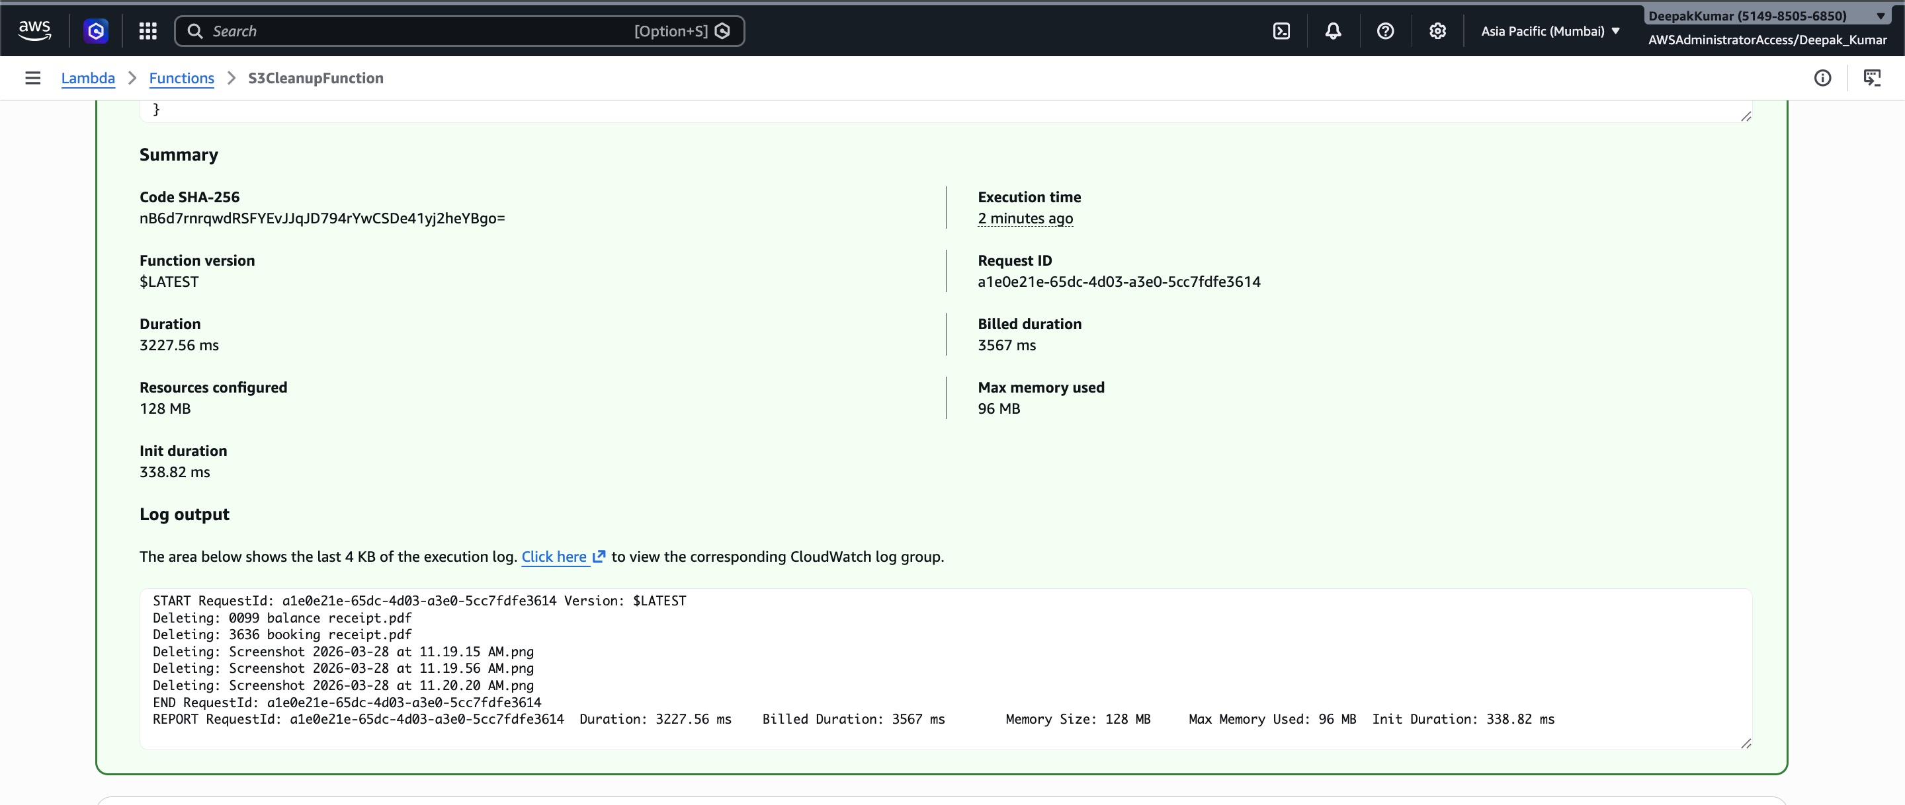

Screenshot After Execution:
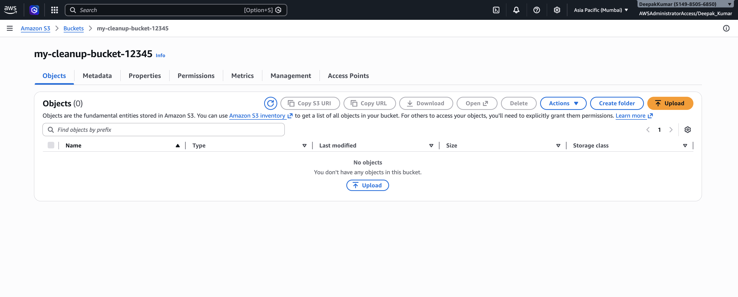

Conclusion
This assignment demonstrates how AWS Lambda and Boto3 can be used to automate storage management in S3 by deleting outdated files, helping to optimize storage usage and cost.

